Radius and Ulna

Ulna
Ulna is the medial bone of the forearm. It is the postaxial bone of the upperlimb
Long axis is in line with humerus
It has upper end, shaft and lower end (head)

Upper end
Olecranon - curved eminence in the upper end, receives insertion of triceps
Coronoid process - triangular eminence project forwards, receives insertion of brachialis
Semilunar notch - articular space between olecranon and coronoid process
Radial notch - narrow depression on the lateral side of olecranon, articulates with radius (lateral bone)

Body (shaft)
Borders - anterior, posterior and lateral border
Lateral border is sharp - interosseous border
Surface - anterior, posterior and medial surface
Generally flexors of the wrist and digits arise from the anterior surface
All extensors arise fom the posterior surface

Lower end (head of ulna)
Articulates with the upper surface of the triangular articular disc
Ulnar styloid process - directed laterally, non-articular projection of the lower end

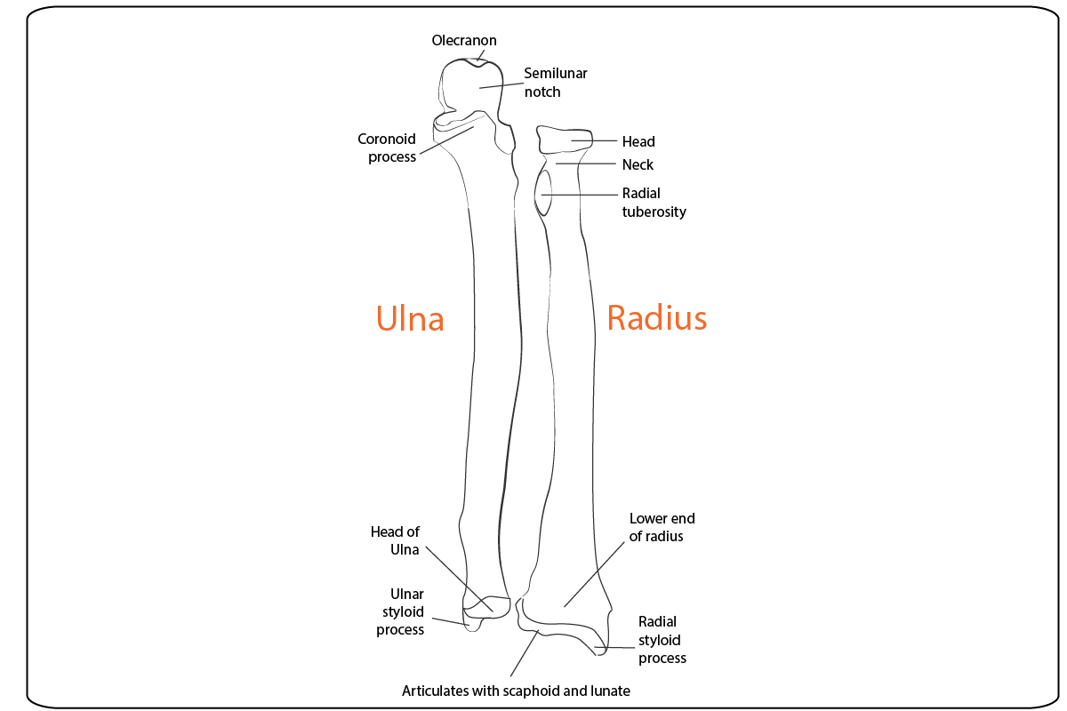

Radius
Radius is the lateral bone of the forearm. It is the preaxial bone of the upperlimb
Weight is transmitted through radius (from hand) and interosseous membrane to ulna, in turn to humerus
Parts of radius - upper end, shaft and lower end

Upper end
Head of the radius - forms joint (humeroradial - hinge) with capitulum of the humerus
Neck - located below the head, this is the usual level of division of brachial artery into radial artery and ulnar artery
Radial tuberosity - located on the medial side. Biceps brachii is inserted into its posterior aspect, separated by a bursa (related to anterior aspect of radial tuberosity)

Shaft
Borders - anterior, posterior and medial border (interosseous border)
Surface - anterior, posterior and lateral surfaces
Generally, flexors of the wrist and digits arise from the anterior surface
All extensors arise fom the posterior surface

Lower end
Large and quadrilateral, has anterior, posterior, medial, lateral and inferior surfaces
Radial artery is palpated over the distal and lateral aspect of the anterior surface of the radius
Inferior surface articulates with the carpal bones (scaphoid and lunate) to form radiocarpal (wrist) joint

